Weekly Research Report Studio 5

Student name :Zihan Liu

Report date : 22/2/2024

What did you do this week?

*Outline briefly what you did this week and what you achieved.*

**Trello dashboard has been created and tasks listed.**

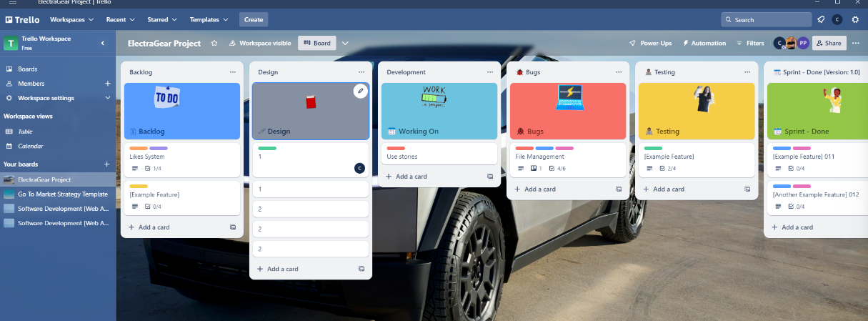

**Working on the requirement analysis report.**

**User stories document finished, website basic functions has been settled.**

What are you planning to do next week?

*Give the handwriting or web design tool to do the main page designing.   
Keep writing the requirement analysis report*

*Keep updating the Trello dashboard, give more tasks.*

*Have few lines code to test the springboots and Vue working environment and prepare for implementation.*

Do you need help with anything?

Any other suggestions for design? Might need some specific tasks to push me forward and gain better design result.  
  
  
I have put the user stories in a document, do I need to put them in Trello as well?   
Thank you